NAME of HOME
Phase 1 ~ Important Visiting Information

one or two visitors
only
*(from the same household)
3.
2. visits are for
Up to 60 mins max
1. please make an
appointment










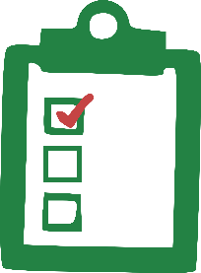
…but lots of love
no gifts
You can book an appointment*
*Children must be supervised and able to social distance. Number of visitors will depend on the home’s facilities. Please contact the Home Manager for an appointment –
garden visit
stand/sit 2m away
4. you must not have symptoms
(Cough, temperature, loss of taste or smell)

window visit
before you visit
please read the visitor information

5.
no touching
6.
stand/sit 2m away

